**NAME: Meet Raut**

**DIV: S21**

**ROLL NO: 2201084**

* **EXPERIMENT – 8:**

* ***AIM:*** **To count number of lines, words and characters in a file. .**
* ***THEORY:***

**Count Number of Lines, Words, and Characters in a File:**

To count the number of lines, words, and characters in a file, you can read the file and then use Python string and list methods to perform the required counts. For example, to count lines, you can split the content based on newline characters (\n). To count words, you can use the split() method, and to count characters, you can use the len() function.

* **PROGRAM 1:**

filename= r"C:\Users\Lenovo\Desktop\S21_2201072\hello.txt"

num_lines = 0

num_words = 0

num_chars = 0

with open(filename, 'r') as file:

for line in file:

num_lines += 1

words = line.split()

num_words += len(words)

num_chars += len(line)

file = open(filename, 'a')

extra_text = "This is extra test India"

file.write(extra_text)

file.close()

print(f"Number of lines: {num_lines}")

print(f"Number of words: {num_words}")

print(f"Number of characters: {num_chars}")

* **OUTPUT:**

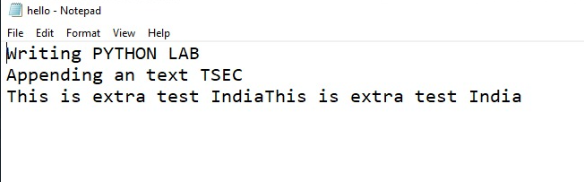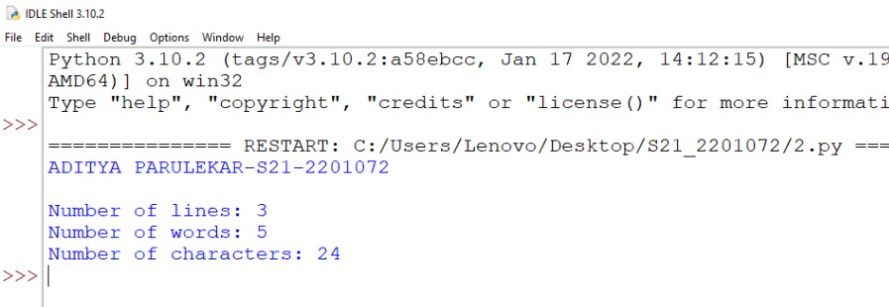

* ***CONCLUSION:*** **Hence, we have successfully implemented program on exploring files and directories; LO 2.**